Spring Boot CorsFilter(全域跨網域) Session資料遺失處置
請用Spring Boot 2.x
pom.xml
<dependency>
<groupId>org.springframework.boot</groupId>
<artifactId>spring-boot-starter-data-jpa</artifactId>
</dependency>
<dependency>
<groupId>org.springframework.boot</groupId>
<artifactId>spring-boot-starter-web</artifactId>
</dependency>
<dependency>
<groupId>javax.servlet</groupId>
<artifactId>javax.servlet-api</artifactId>
<version>4.0.1</version> <!-- 根據您的版本進行調整 -->
<scope>provided</scope>
</dependency>
<dependency>
<groupId>com.mysql</groupId>
<artifactId>mysql-connector-j</artifactId>
<scope>runtime</scope>
</dependency>

application.properties

spring.datasource.url=jdbc:mysql://localhost:3306/demo
spring.datasource.username=root
spring.datasource.password=1234
spring.datasource.driver-class-name=com.mysql.cj.jdbc.Driver

spring.jpa.show-sql=true
spring.jpa.properties.hibernate.format_sql=true
spring.jpa.properties.hibernate.hbm2ddl.auto=create-drop

spring.jpa.hibernate.naming.implicit-strategy=org.hibernate.boot.model.naming.ImplicitNamingStrategyLegacyJpaImpl
spring.jpa.hibernate.naming.physical-strategy=org.hibernate.boot.model.naming.PhysicalNamingStrategyStandardImpl

import jakarta.persistence.*;
@Entity
public class MyData {
@Id
@GeneratedValue(strategy = GenerationType.IDENTITY)
Integer id;
String user;
String phone;
int age;

public MyData() {}
public MyData(String user, String phone, int age) {
this.user = user;
this.phone = phone;
this.age = age;
}
public Integer getId() {
return id;
}
public void setId(Integer id) {
this.id = id;
}
public String getUser() {
return user;
}
public void setUser(String user) {
this.user = user;
}
public String getPhone() {
return phone;
}
public void setPhone(String phone) {
this.phone = phone;
}
public int getAge() {
return age;
}
public void setAge(int age) {
this.age = age;
}
@Override
public String toString() {
return "MyData [id=" + id + ", user=" + user + ", phone=" + phone + ", age=" + age + "]";
}

}

import org.springframework.data.jpa.repository.JpaRepository;

public interface MyDataService extends JpaRepository<MyData, Integer>{
}

import org.springframework.beans.factory.annotation.Autowired;
import org.springframework.boot.CommandLineRunner;
import org.springframework.boot.SpringApplication;
import org.springframework.boot.autoconfigure.SpringBootApplication;
import com.example.demo.model.*;
@SpringBootApplication
public class Sbcorssession202308Application implements CommandLineRunner {
@Autowired
MyDataService userService;
public static void main(String[] args) {
SpringApplication.run(Sbcorssession202308Application.class, args);
}
@Override
public void run(String... args) throws Exception {
MyData m1=new MyData("Annie","0x123",20);
MyData m2=new MyData("Betty","0x456",25);
MyData m3=new MyData("Cindy","0x789",23);
userService.save(m1);
userService.save(m2);
userService.save(m3);
}

}
至此請執行Spring Boot App 看看資料庫是否有3筆MyData資料

import org.springframework.beans.factory.annotation.Autowired;
import org.springframework.stereotype.Controller;
import org.springframework.web.bind.annotation.GetMapping;
import org.springframework.web.bind.annotation.PathVariable;
import org.springframework.web.bind.annotation.RequestMapping;
import org.springframework.web.bind.annotation.RequestMethod;
import org.springframework.web.bind.annotation.ResponseBody;

import java.util.*;
import com.example.demo.model.*;

import jakarta.servlet.http.HttpSession;

@Controller
@RequestMapping(value={"/data"})
public class MyDataController {

@Autowired
MyDataService userService;

@RequestMapping(method=RequestMethod.GET)
public @ResponseBody List<MyData> getAll(HttpSession session ){
List<MyData> data=userService.findAll();
session.setAttribute("userdata", data);
System.out.println("getAll userdata session id is "+session.getId());
return data;
}
@GetMapping("/{id}")
public @ResponseBody MyData getById(@PathVariable("id") int id ,HttpSession session ){
List<MyData> md=(List<MyData>)session.getAttribute("userdata");
System.out.println("{id} userdata session id is "+id+" "+session.getId());
if(md!=null) {
MyData m=md.stream().filter(d->d.getId()==id).findFirst().get();
System.out.println(m);
return m;
}
else {
return null;
}
}

}

利用postman:
- http://localhost:8080/data
- http://localhost:8080/data/2

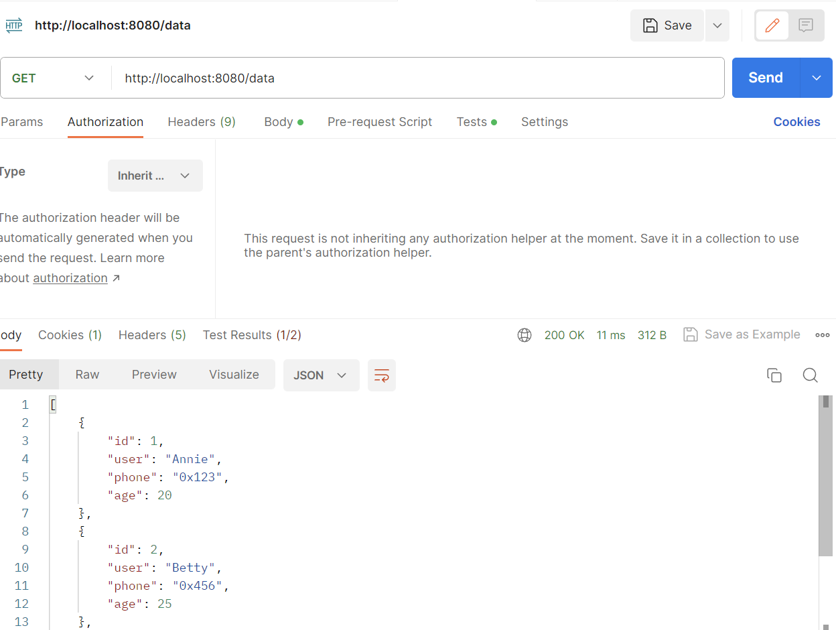

在vscode 寫一隻react js
import React, { useState, useEffect } from 'react';

const ComponentSession = () => {
const [data, setData] = useState([]);
const [selectedData, setSelectedData] = useState(null);

useEffect(() => {
// 呼叫getAll API來取得所有資料
fetch('http://localhost:8080/data', {
method: 'GET',
credentials: 'include' // 保留session cookie
})
.then(response => response.json())
.then(data => setData(data))
.catch(error => console.error('Error fetching data:', error));
}, []);

const handleGetDataById = (id) => {
// 呼叫getById API來取得特定ID的資料
fetch(`http://localhost:8080/data/${id}`, {
method: 'GET',
credentials: 'include' // 保留session cookie
})
.then(response => response.json())
.then(data => setSelectedData(data))
.catch(error => console.error('Error fetching data by id:', error));
};

return (
<div>
<h2>All Data:</h2>
<ul>
{data.map(item => (
<li key={item.id}>
<button onClick={() => handleGetDataById(item.id)}>
{item.user} - {item.phone}
</button>
</li>
))}
</ul>
{selectedData && (
<div>
<h2>Selected Data:</h2>
<p>Name: {selectedData.user}</p>
<p>Description: {selectedData.phone}</p>
{/* 這裡顯示其他資料欄位 */}
</div>
)}
</div>
);
};

export default ComponentSession;

import org.springframework.context.annotation.Bean;
import org.springframework.context.annotation.Configuration;
import org.springframework.security.config.annotation.web.builders.HttpSecurity;
import org.springframework.security.config.annotation.web.configuration.EnableWebSecurity;
import org.springframework.security.web.SecurityFilterChain;
import org.springframework.web.cors.CorsConfigurationSource;
import org.springframework.web.cors.UrlBasedCorsConfigurationSource;
import org.springframework.web.filter.CorsFilter;
import org.springframework.web.cors.CorsConfiguration;

@Configuration
@EnableWebSecurity
public class SecurityConfig {

@Bean
public SecurityFilterChain securityFilterChain(HttpSecurity http) throws Exception {
http
.authorizeRequests(authorize -> authorize
.anyRequest().permitAll()
)
.csrf().disable();

return http.build();
}

@Bean
public CorsFilter corsFilter() {
CorsConfiguration config = new CorsConfiguration();
config.addAllowedOrigin("http://localhost:3000"); // 替換為實際的來源地址
config.setAllowCredentials(true);
config.setAllowedMethods(List.of("GET", "POST", "PUT", "DELETE"));
config.setAllowedHeaders(List.of("/*"));
config.setExposedHeaders(List.of("/*"));
//config.addExposedHeader("Content-Type", "X-Requested-With");

UrlBasedCorsConfigurationSource configSource = new UrlBasedCorsConfigurationSource();
configSource.registerCorsConfiguration("/**", config);

return new CorsFilter(configSource);
}
}

